Instafy: A social network based around music

Intro & Goal

A new social site that allows you to connect to your Spotify account and display you’re music persona via a curated profile. Friends can comment, like and share posts. Think: An Instagram for music.

Who’s it for?

This social site is for anyone who uses Spotify and wants to connect with friends about all things music.

Timeline

* 4 weeks

Scope of Project:

* Users sign up on the platform with their Spotify account
* Users can find friends by connecting to their Facebook account
* follow/unfollow functionality
* Comment, like and share functionality
* Messaging platform to send new content to friends
* Users curate their profile with their favorite artists, albums and songs which they can select from their Spotify profiles
* Users can browse through their feed of updates from friends

Features:

Signing up:

* Sign up/ login flow
* Connect to Spotify

Profile:

* Profile picture
* Create username
* Text profile description
* Followers/Following friends
* Public/ private profile

Feed/Posts:

* Upload my favorite artists, songs and albums from Spotify (either by search or from my profile)
* Write captions and link songs to each of my posts before I upload
* Friends can like, comment or listen to the music synced with the post
* Delete past posts
* Share posts within the platform via private message

Messaging:

* Message friends about a specific post in a private chat

Search:

* Search friends via username
* Search for albums, artists or playlists

Mockups

**Login with Spotify**

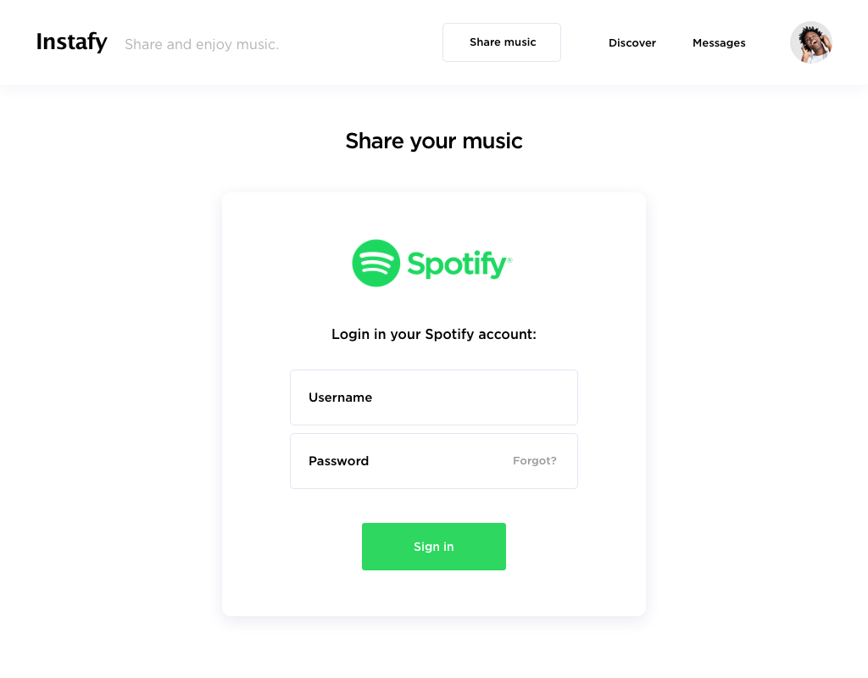

**Profile:**

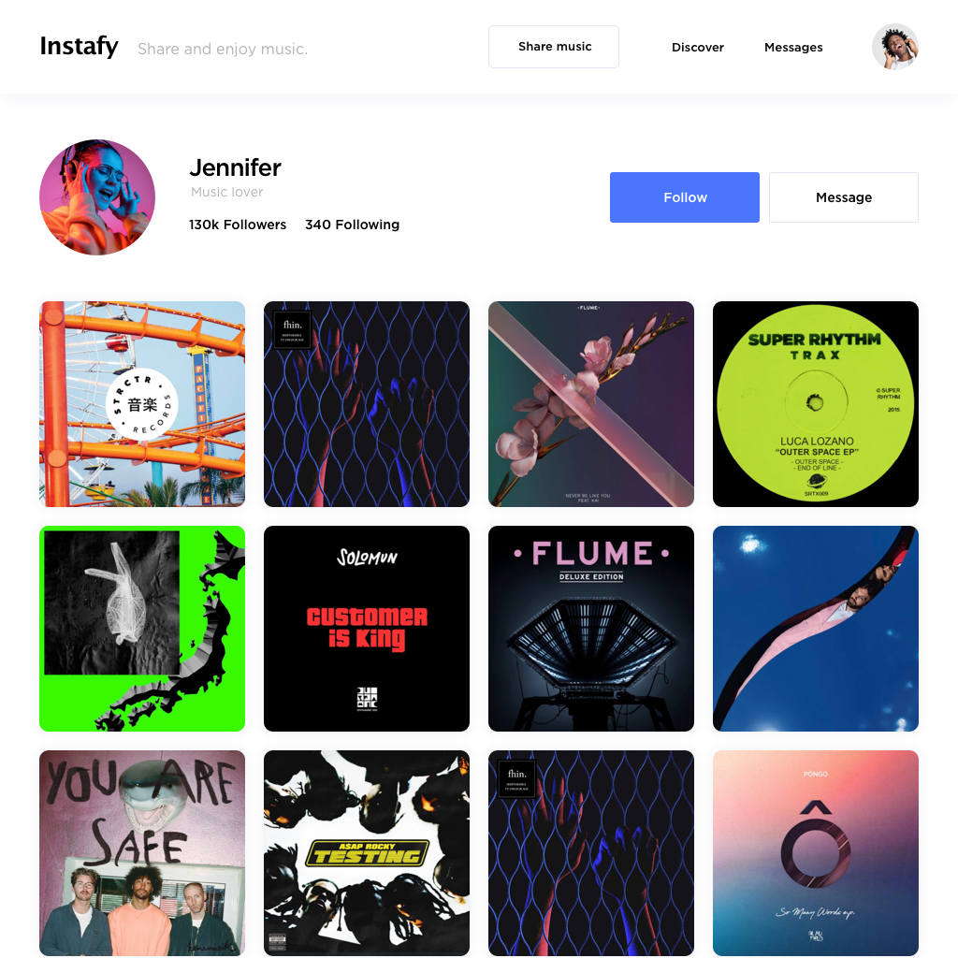

Details:

* Follow sends a notification to the user that you want to follow them
* “Discover” goes to your feed (those you follow and popular posts of those you don’t follow)
* “Message” goes into a private chat with the user
* “Share music” goes to upload a post

**Individual post:**

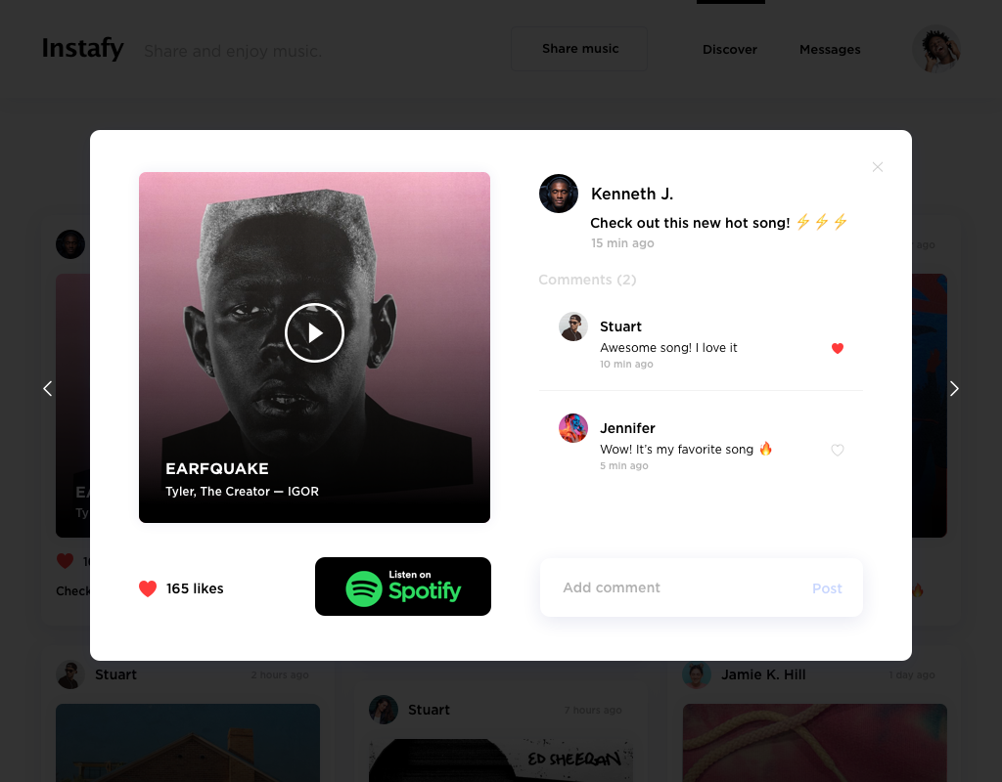

**Upload a post:**

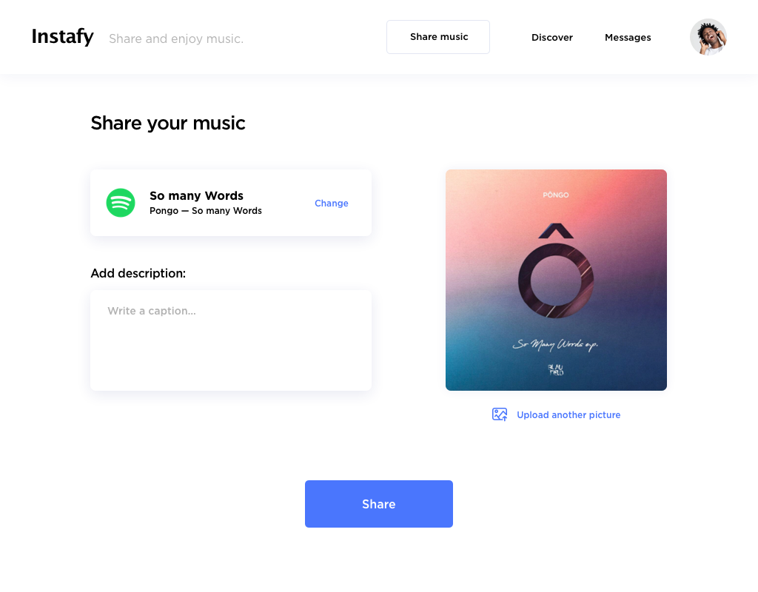

Details:

* Have the ability to change the picture attached to the song/ album (choose a picture in your own photo library on your phone

**Feed:**

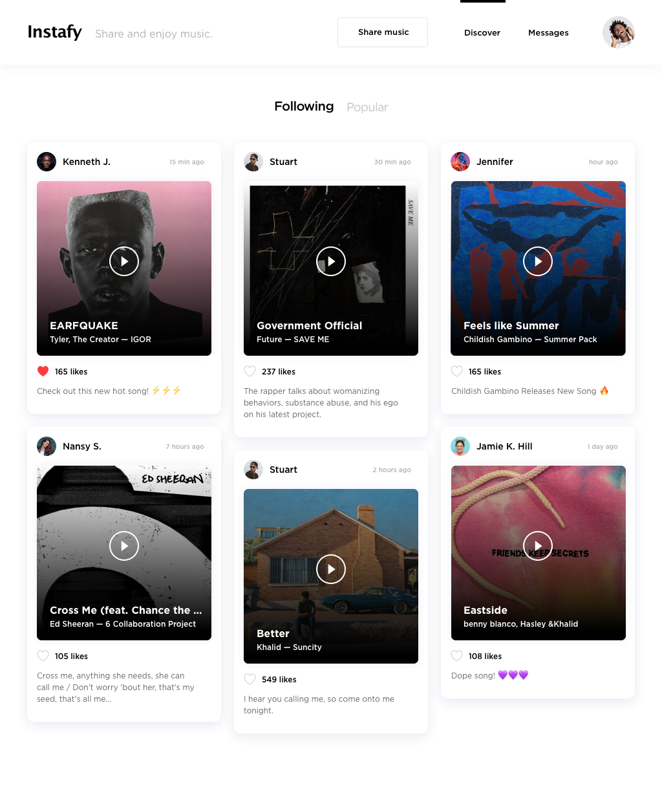

Details:

* ‘Popular’ are public posts from other users who you don’t currently follow

**Private Message:**

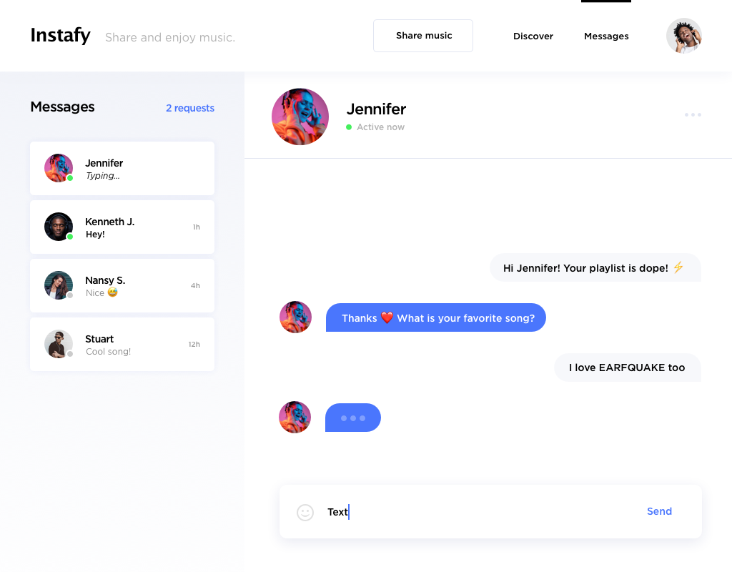

Not in scope (for this version):

* Tagged posts
* Saved posts
* Suggestions/ recommendations
* Stories

Inspirational sites:

* www.instagram.com